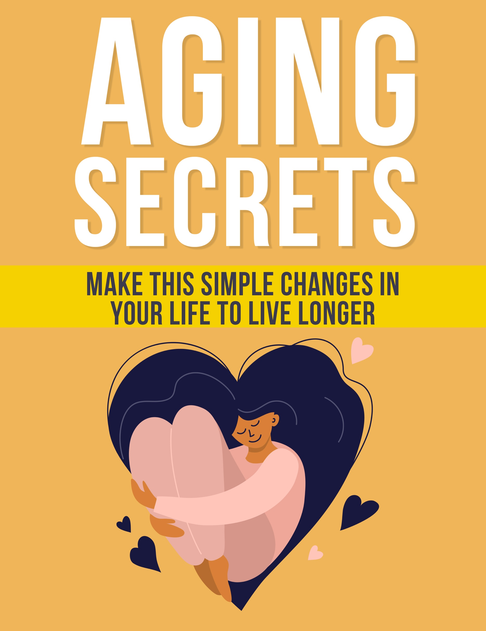

Aging Secrets
The Secrets To Living Longer By Looking Younger And Feeling Younger

Table of Contents
Introduction 4
The Importance of regularly Visiting your Doctor 7
Regular Doctor Visits can help to Prolong your Life 7
Forget about Self-Diagnosis 8
Get a Comprehensive Checkup 8
The Benefits of Getting Outside More 10
The Importance of Vitamin D 10
How Vitamin D helps you 11
Get Enough Sleep But Don’t Overdo It 12
A Consistent Sleeping Habit is Essential 12
The Link between Sleep and Longevity 13
The Importance of Socializing 15
It is not totally clear why Socializing helps with Longevity 15
Maintain a Positive Social Circle 16
Improve your Communications with others 17
Provide your Support to others 18
Your Diet is Essential for your Longevity 19
Change your Lifestyle to Change your Diet 20
Consider Intermittent Fasting 21
The Importance of Exercising your Body and your Brain 23
Increase your Muscle Mass and Longevity with Exercise 23
Exercise your Brain 25
Drink Water for Longevity 26
Drink More Water to Reduce Cravings for Sugar 26
Conclusion 28
Essential Resources 29
13 Habits Linked to a Long Life (backed by science) 29
https://www.healthline.com/nutrition/13-habits-linked-to-a-long-life 29
6 Steps to a Better Sleep 29
https://www.mayoclinic.org/healthy-lifestyle/adult-health/in-depth/sleep/art-20048379 29
Eating for Longevity 29
https://www.webmd.com/healthy-aging/features/longevity-foods 29
How your Mindset can Change how you Age 29

Introduction
We all want to live as long as we can. Advances in medicine have helped us to do this as they eliminate fatal diseases that killed off our ancestors many years ago. These days, it is very rare to die from the kind of diseases that shortened the lives of people in the past.
Around a century ago, getting an infection could mean death. The advancements in antibiotic medication have now made this significantly less likely. In the past, diabetes killed many people but today you can take insulin to protect you from dying.
You need to be grateful that you are alive today. The average lifespan of a human being has increased significantly over the last few years. Just over a century ago most people did not reach the age of 50. Now the average lifespan is around 80 years.
The good news doesn’t stop there. There are things that you can do to give yourself an even better chance of living longer. You are going to find out what these things are in this special “Aging Secrets” report.
We encourage you to read every word of this valuable report. It contains strategies to help you to live longer and be happier than you are right now by making some simple but powerful lifestyle changes.
All of the methods that are revealed in this report are backed by science.
So, let’s get started on how you can live longer, be happier, and look younger as well!
In the first section, we will explain the importance of regular visits to your doctor…

The Importance of regularly Visiting your Doctor
You need to know if you are healthy or not and the best way to achieve this is to visit your doctor. A lot of people, especially seniors, do not visit their doctor on a regular basis because they assume that they are healthy. Do not make this same mistake.
As you get older, it is natural for you to experience twinges and pains that you have not experienced before. These may only appear for a short time and then disappear.

Regular Doctor Visits can help to Prolong your Life
If you want to prolong your life then ensure that you see your doctor regularly. We are all busy these days and it is tempting to avoid visiting the doctor for small aches and pains. You believe that they will go away in a short time. But what if they don’t go away?
You don’t want to risk ending up in the emergency room for something that you ignored in the past. These days, a lot of health problems can be rectified if your doctor can diagnose them early enough. If you do not go for a regular doctor’s checkup then you are not going to know if there is something that requires quick medical attention.

Forget about Self-Diagnosis
The Internet is one of the greatest inventions ever. Today, you can use a search engine like Google to find the answer to just about every question under the sun. This presents a problem as the tendency these days is for people to self-diagnose what is wrong with them.
Something else that is trending is the number of searches for home remedies. More and more people are trying to fix their own health problems by using these natural home remedies. But this can be a big mistake. If you are feeling unwell then go and see your doctor. Your doctor will have a much greater chance of curing you of your ailments if you tell them about your health problems early.

Get a Comprehensive Checkup
There is nothing more important in your life than your health. If you are in the United States then you probably have health insurance cover. Nowadays, a lot of health insurance policies demand that the policy holder has a comprehensive annual checkup and they will pay for this as part of the policy.
What do we mean by comprehensive? We are talking about the full works here such as x-rays, EKGs and MRI scans. There are other modern health scanning techniques that you can discuss with your doctor.
A lot of people die from coronary artery disease and aneurisms and don’t even know that they have these problems. Don’t take the risk of not knowing how healthy you are. It is also a good idea to know your family history. Some health issues can be passed on and it is worth checking this with your doctor as well.
Having the most comprehensive health scans using the latest technology may not be covered by your health insurance policy. Speak to your insurer to see what is covered and what isn’t. If you have to pay for the scans out of your own pocket then we recommend that you do this. Your health has to be your number one priority.
In the next section, we will discuss the benefits of getting outside more…

The Benefits of Getting Outside More
Are you getting outside as much as you can so that you are exposed to sunlight? Getting outside in the sunlight is very effective to make you feel happier and science has proven that it can improve your well-being and help you to live longer.

The Importance of Vitamin D
Why are we recommending that you get outside more? It is because when you expose yourself to sunlight it increases the amount of vitamin D in your body. Most people spend far too much time indoors these days and they are depriving themselves of this essential vitamin. Do you get outdoors regularly?
It does not have to be hot outside for you to benefit from the sun’s rays and vitamin D. You do not have to spend a lot of time exposing yourself to sunlight either. Just 15 minutes per day is enough. As long as you can expose your face and hands to sunlight during this time.
You may have heard that too much exposure to sunlight can be harmful. This is true as the ultraviolet light in the sun’s rays can cause skin cancer and burns if you are exposed to sunlight for too long. Believe us when we tell you that 15 minutes of direct exposure to sunlight is all that you need to get that much needed vitamin D.

How Vitamin D helps you
There are several benefits to getting the right amount of vitamin D every day. These include:
- Making your bones healthy
- Preventing the onset of depression
- Preventing heart disease
- Preventing diabetes
The bottom line is that the right amount of vitamin D is essential for good health and preventing the negative effects of aging. When you venture outside into the sun you will feel good and it will help you in many ways.
In the next section, we will discuss the importance of getting enough sleep…

Get Enough Sleep But Don’t Overdo It
Are you getting enough sleep every night? These days, far too many people are not getting the right amount of sleep for a variety of reasons. Modern life is very stressful at times and a lot of people find it very difficult to relax.
If you find it tough to get a consistent good night’s sleep every night then you need to fix this as a priority. You will see in this section how important it is that you get enough sleep each day. Failure to do this can be detrimental to your health and result in you aging a lot faster than you should do.

A Consistent Sleeping Habit is Essential
There have been numerous scientific studies into the importance of sleep. A study conducted fairly recently showed that a consistent sleeping habit is critical for living a longer live and overall health and wellbeing.
What is a consistent sleep habit? It is about going to sleep at the same time each night and waking up at the same time every morning. If you have not had a good sleep the previous night then you feel bad the next day, don’t you? This is OK now and again, but if it is a regular thing then your health is going to suffer. You will also age a lot faster which of course you want to avoid.
Children require more sleep than adults do. A child up to their teenage years should be getting around 10 hours of sleep a day. An adult requires a minimum of 6 hours of sleep and it is better if you can make this 7 or 8 hours.

The Link between Sleep and Longevity
Studies have confirmed that not getting enough sleep will increase your risk of dying earlier by as much as 12%. When you sleep your body repairs itself. It goes to work on repairing your cells which is essential for good health.
People that do not get sufficient sleep are more likely to suffer from obesity, diabetes and heart disease. None of these will help you to live longer. They will have the opposite effect and shorten your lifespan.
Getting too much sleep is not a good thing either. If you sleep for too long (more than 9 hours each night) then you run the risk of shortening your lifespan by as much as 38%. You need to get the balance right when it comes to the number of hours that you sleep every night.
The problem with sleeping too much is that it limits your physical activity. It can also result in depression. Neither of these things are good for your lifespan. If you have a sleeping problem then you must fix this as a matter of urgency. There is plenty of information online about how to do this and there are effective sleep aid products available too.
In the next section, we will discuss the importance of socializing…

The Importance of Socializing
The Covid-19 pandemic has made socializing more difficult than it used to be. But science has proven that people who are better connected with friends and family tend to be healthier than those that are not. Studies have proven that spending time with family members and friends can prolong an individual’s lifespan.
How much time are you spending with your friends and family? If you cannot meet with them physically due to pandemic restrictions, are you taking advantage of video conferencing solutions such as Zoom to stay connected?

It is not totally clear why Socializing helps with Longevity
Despite all of the studies which prove socializing is an effective way to increase your lifespan, the scientists do not know exactly why this works. This doesn’t mean that you should ignore the benefits of socializing. There are many things that are good for us in life that scientists cannot explain.
Experts believe that having positive relationships with a partner, family members and friends helps prolong your life because they help to reduce your stress levels. This is a theory that we certainly support.
Another sound reason is that when a person is in a positive relationship with a partner, they will probably take greater care of themselves than if they were single. They are also less likely to avoid taking dangerous risks as they want to be with their partner for as long as possible.

Maintain a Positive Social Circle
Scientists have stated that maintaining a positive social circle can help you to increase your lifespan by as much as 50%. If you have difficulty in forming positive relationships with others then there are things that you can do about this.
The experts state that if a person has only 3 positive social connections, they will reduce the risk of dying early by around 200%. So, the next time you are hesitating about forming a new relationship with someone, keep this statistic in mind.
When you have positive social connections, you are more likely to create positive changes in your body. Here are some of the things those good social connections can do for you:
- Improve your brain
- Boost your immune system
- Improve your heart health
- Improve your hormonal activity
All of these things are good and will help to prevent you from getting any chronic diseases. Think about the amount of time you currently spend in the company of your family and friends. What can you do to increase this? You do not have to physically meet, a Zoom meeting or even a phone call will have a positive effect.

Improve your Communications with others
By improving the way that you communicate with your friends and family you will strengthen the connection that you have with them. Everyone likes a good story so do a lot more things with your friends and family so that you have some great stories to tell.
You can tell your family some funny stories about the time that you had with your friends and tell your friends about those funny family stories. We all love to hear good stories and these help to strengthen the bond between people.
If you do not have family members and friends living nearby or your options are limited for whatever reason then you need to make some new connections. There are lots of things that you can do here such as joining a social club or even becoming a local volunteer. Learn new skills by taking classes and make new friends at the same time.

Provide your Support to others
Several studies have shown that people that provide support to others tend to be healthier and have a long lifespan. There is a great deal of satisfaction to be gained from providing your support to others.
Take the view that it is better to give than it is to receive. All of us need the support of others from time to time. But when you are the one providing the support, it is very likely to make you a lot happier and help you to maintain a positive mood. These things increase our self-worth and this is a significant factor in living longer.
In the next section, we will discuss the importance of your diet and longevity…

Your Diet is Essential for your Longevity
If you were expecting there to be a section on how important your diet is for your longevity then we have not disappointed you! Your diet is crucial for living a longer life so please pay special attention to this section.
Studies have shown that there are 3 factors of your diet that have a direct link to your lifespan. These are:
- Avoiding obesity
- Increasing the amount of antioxidants you consume
- Minimizing the bad fats that you consume
Does this mean that you have to be a vegan to live longer? No, you can consume the right amount of antioxidents and minimize the bad fats by eating the right things.
You probably already know the foods that are good for you and those that are not. Junk food is definitely not good for you. It is OK occasionally. The following foods are good for you:
- Fresh fruit
- Fresh vegetables
- Water
- Lean meats and fish
At the same time, you need to aim to consume less sugar, fewer saturated fats and less carbohydrates.

Change your Lifestyle to Change your Diet
If you want to successfully transition from an unhealthy diet to a healthy one then you need to make a commitment to change your lifestyle. When you are sitting down watching TV don’t reach for a candy bar or a bag of chips. Eat nuts instead or a stick of celery or a piece of fresh fruit.
How big are the portions of food that you eat at meal times? Most people have far too much on their plate during a meal. It is very easy to get into the habit of eating too much and not so easy to break this. A lot of people will make the potatoes the largest portion of their meal. Potatoes are starchy and they should be the smallest portion.
Do you tend to consume a lot of sugary drinks? If so, drink water instead or tea without sugar. It is not difficult to reduce the size of the portions on your plate. You can use the “plate” method where you use a smaller sized plate for your meals rather than a large one. Make sure that half of this smaller plate contains fresh vegetables or fruit.
For the remaining half of your plate, you need to divide this into two quarters. One of the quarters will contain your meat portion and the final quarter will contain starchy food such as potatoes, bread or pasta.
Eating raw food is also a good idea. Most foods that are consumed raw are better for you than if they are cooked. This is the case with the majority of vegetables and fruits. Be careful here. We are not suggesting that you eat raw potatoes for example. Keep the skin on any raw vegetables you consume.
It is better for you to consume whole grain bread and rice than the white variety. Resist the temptation to consume processed meats such as sausages or bologna. In addition to this, you need to watch your salt intake. Avoid using a lot of salt when cooking. Keep your salt consumption down to moderate levels.

Consider Intermittent Fasting
There have been studies which prove the benefits of intermittent fasting. This is not always easy to do but if you are determined and persevere with it you can derive some incredible health benefits.
You can start by skipping certain meals. Some people find success with limiting their intake of calories for 2 to 3 days per week. An effective intermittent fasting method is to eat your last meal of the day earlier than usual and then do not eat anything else until breakfast the following morning. If you eat your last meal early enough you can experience fasting for as long as 20 hours.
It doesn’t matter what method of intermittent fasting that you choose. What does matter is that when you eat you are getting all of the nutrients that your body needs. If you like the idea of just skipping certain meals then do not do this for more than 2 days consecutively.
In the next section, we will discuss the importance of exercising both your body and your brain…

The Importance of Exercising your Body and your Brain
You were expecting exercise to be in this special report too, weren’t you? The reason that it is here is because studies have shown that a sedentary lifestyle is linked to a shorter lifespan.
The amount of muscle mass that you have is usually a good indicator of your longevity. As we get older, it is natural for us to lose our muscle mass due to a condition known as sarcopenia (sometimes called flesh poverty). But you do not have to put up with this muscle mass loss.

Increase your Muscle Mass and Longevity with Exercise
If you have a negative perception of exercise then we recommended that you change this immediately. By participating in regular exercise, you will help to increase your muscle mass. You create additional stem cells through exercise and it is good for a healthy heart too.
You have a number of cells that are “undifferentiated” in your body and these can transform into other cell types when they are required. You may need more skin cells, liver cells, lung cells or heart cells for example. Exercise also helps to build your stamina which is important for your balance.
A study that appeared in the British Journal of Nutrition discovered that male seniors that went on a 3 month resistance training regime consisting of 3 sessions each week, ended up with greater motor control, a lower fat mass and an increase in muscle strength.
In another study, the participants went through a vigorous exercise routine for 3 hours a week. The result was that their DNA and cells were 9 years younger than people that had not been through the same routine. It only took around half an hour of exercise each day to achieve this. Exercising every day is always more effective than sessions on alternate days for example.
You are more likely to keep going with your exercise if you commit to it every day. The problem with exercising on alternate days is that if you miss a day then you can end up with 3-4 days where you do not exercise at all. This can be the beginning of the end.
Another reason to exercise on a daily basis is that it will help to increase your energy levels. It is more important for your longevity if you exercise each day rather than only on alternate days.
We do not recommend that you join your local gym and work yourself to death. This is especially true if you have not exercised in a while. Start slowly by walking each day. Leave the car at home and walk to the store instead. There are other things that you can do such as yoga, stretching exercises, cycling and more. Make sure that you exercise for at least 30 minutes each day.

Exercise your Brain
Every time that you do something new you will challenge your brain. Learning a new skill is a great way to challenge your brain. You can attend a local class or learn a new subject online. If you like solving puzzles then this is good for your brain. Sudoku and other puzzles will test you.
New experiences are important for your brain. This is why learning new things is so good for your brain. Commit to learning new things every day. The more that you work your brain, the younger it will become.
In the final section, we will discuss why drinking more water is good for your longevity…

Drink Water for Longevity
What kind of things do you drink? A lot of sodas and fruit juices contain high amounts of sugar which will not prolong your life. The truth is that there is a lot of sugar in beverages these days and you are much better off just drinking water.
Consuming too much sugar is bad for your heart. It also increases your risk of diseases like diabetes. Your liver does not cope well with large amounts of sugar and will turn most of it into fat. Too much sugar can cause your blood pressure to elevate and increases the risk of inflammation. All of these things can result in premature death.

Drink More Water to Reduce Cravings for Sugar
Many people have an addiction to sugar without even knowing it. They say that they have a “sweet tooth” but this just means that they crave sugar. By drinking more water you can reduce these cravings and keep your weight down.
There are other advantages to drinking more water such as improving your mood and enhancing your memory. Water can also prevent problems such as bladder infections, kidney stones and constipation.
You may not know that water provides protection for your joints, your spinal cord and your tissues. It also keeps your body temperature regular. Drinking water when you are exercising will help you to perform better as well.

Conclusion
In this special report you have learned that there are changes that you need to make to prolong your lifespan. You are in control of your lifestyle and the things that you consume.
One of the most important things that you can do to prolong your life is to make a commitment to be happy. Change your current mindset to a positive and happy one. Avoiding emotions such as anger will help to reduce your stress.
A number of studies support this concept. It was proven that people who had an optimistic and happy outlook on life were 18% more likely to live longer than pessimistic people. Having a negative outlook on life will increase the risk of chronic stress and it will certainly make you unhappy. If you are a pessimist then you need to change this now to prolong your lifespan.
Regularly relax your mind and body. Mindfulness meditation is an effective way to do this. Even playing soothing music can help. Learn to breathe deeply so that you can reduce stress and clear your mind.
Follow the advice in this special report to prolong your life!

Essential Resources

Use these essential resources to help you to live a happier and longer life:

13 Habits Linked to a Long Life (backed by science)

https://www.healthline.com/nutrition/13-habits-linked-to-a-long-life

6 Steps to a Better Sleep

https://www.mayoclinic.org/healthy-lifestyle/adult-health/in-depth/sleep/art-20048379

Eating for Longevity

https://www.webmd.com/healthy-aging/features/longevity-foods

How your Mindset can Change how you Age
https://time.com/3706720/how-your-mindset-can-change-how-you-age/

